

**Automated Water Tank & Water Usage Monitoring System**

|  |  |
| --- | --- |
|  | **Submitted By** |
|  |  |
| 16-31661-1 | Mohoshen Mubashir Prantha |
|  |  |
| 16-32748-3 | Fayaz, Fahim |
|  |  |
| 17-34944-2 | Mahfuz, Sadman |
|  |  |
| 18-38138-2 | Md Fajlay Rabbi |
|  |  |
| 15-30490-3 | Nibir Ashik Mahmud |
| 16-32315-3 | Haque, Md. Mozammel |

**Department of Computer Science**

**Faculty of Science & IT**

**American International University Bangladesh**

**September, 2020**

**Table of contents**

|  |  |
| --- | --- |
| **1** | **Abstract** |
| **2** | **Features & Components** |
| **3** | **Project Description** |
| **4** | **Wiring of electronics** |
| **5** | **Schematic** |
| **6** | **Setting up the Blynk App** |
| **7** | **Programming the NodeMCU** |
| **8** | **Results & Discussion** |
| **9** | **Conclusion & Future Scope** |
| **10** | **Reference** |

**List of figures & Diagrams**

* Flow Chart
* Circuit Diagram

**1. Abstract**

Our project is focused on creating such a system using IOT which monitors detailed usage of water in every household. As drinking water is very precious to mankind and we are running low on drinking water as we speak. One of the main reasons is unjustified economical use of water and another is lack of monitoring devices in developing countries like Bangladesh. The real time observation of water usage in every house of every building in our country will give an exact calculation of water usage floor by floor to the landlords. Also, real time observation of water levels in tanks. So, our project will help to monitor water usage through flow level and classify it according to that. This will be implemented through acquiring data and internet of things (IOT). That will work through water flow sensors, water level sensors and Wi-Fi protocol and the user will be notified through the software. The software will contain data of usage of water of a building as a whole as well as of an individual floor, so the user will be able to see the information.

WASA Authorities/ Landlords by using our project can determine the exact usage of water by any individual floor of a building and thus charge the user accordingly.

**2. Features and Components**

Automated Water Tank & Water Usage Monitoring System consists of these specific features:

1. Wireless Monitoring of water flow for each floor
2. On and off if the tank is full or empty
3. Observe the system using an app
4. Control each floor water usage if water is being waste
5. Push notification for tank full or empty

Below are the hardwire components we used to implement the device:

1. ESP32 ESP-32S NodeMCU Development Board built-in Wi-Fi
2. Relay module
3. Water motor pump
4. Water Flow sensor
5. 3 Water Level Sensors
6. DC-DC Buck & Boost Converter
7. 3mm Red light
8. 11.1V 1100mAh 3s 30C LIPO Battery

These components were ordered from an online tech shop known as Speedy tech ( [bdspeedytech.com ).](https://bdspeedytech.com/)

Our estimated budget to implement the project is 3,500TK in total. We are planning to host the real time data into a public cloud server.

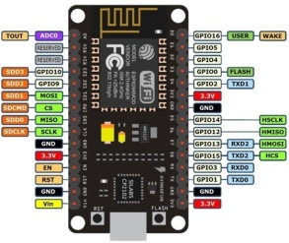 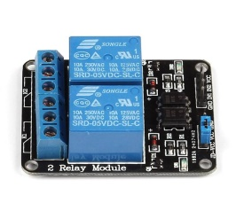 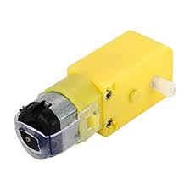 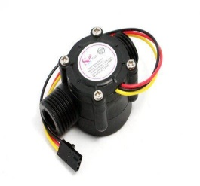

Figure : Node MCU Figure : Relay Figure : Motor Pump Figure : Water Flow Sensor

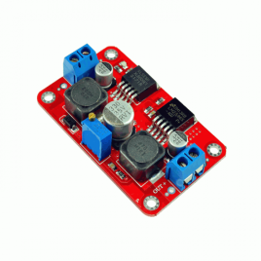 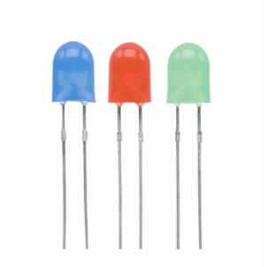 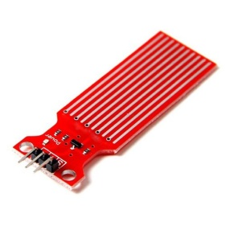 

Figure : Buck Converter Figure : LED lights Figure : Water Level Sensor Figure : Battery

**3. Project Description**

A battery is used to power the sensors and modules.

The 3 water level sensors are set at 3 positions namely, low, medium and high.

* When sensor detects low water, a signal is passed to the app showing low water level. Red light on the device turns ON and Water Pump turns ON.
* When sensor detects medium water, a signal is passed to the app showing medium water level. Red light on the device stays ON and water pump stays ON until water reach high.
* When sensor detects high water, a signal is passed to the app showing high water level. Red light on the device turns OFF and water pump also turns OFF.

It is to be noted that water pump is not included in our project. Instead a red light has been used to represent the status of the water pump.

* Redlight ON = pump ON
* Redlight OFF = pump OFF

The Flow sensor is set in a pipe supplying water to an entire floor. The Flow sensor is instructed some parameters. When water flow exceeds the given limit, the flow sensor sends signal to the NodeMCU and the NodeMCU triggers the motor to block the pipe supplying water. The admin can later unblock the pipe using the app.

It is to be noted that the motor we are using here represents a key which can block and unblock a pipe supplying water to a certain floor. When the Flow sensor senses too much water being wasted it, it triggers the motor and the pipe is blocked.

**Flow Chart**

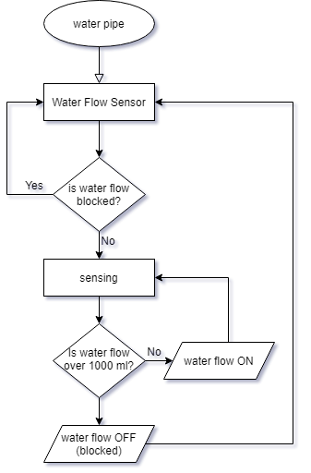

**Fig: Water Flow Sensing Flow Chart**

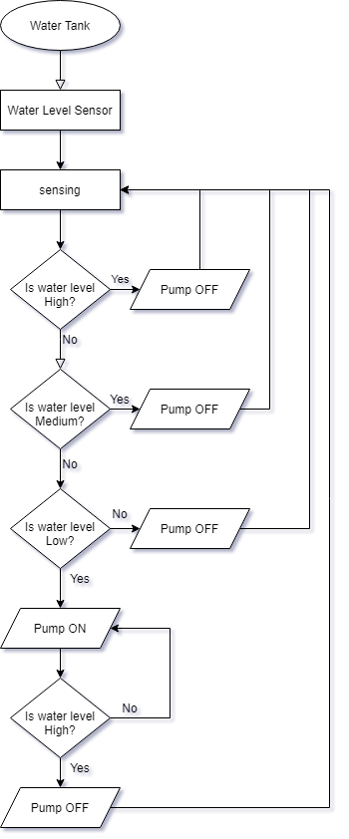

**Fig: Water Level Sensing Flow Chart**

**4. Wiring of Electronics**

**Step 1:**

A buck converter is used to convert the 11.1V battery to give out 5V to the sensors and modules.

**Step 2:**

Sensor connection with NodeMCU and power supply:

|  |  |  |  |
| --- | --- | --- | --- |
| Sensor/module | (+) ve | (-) ve | Signal port  (nodeMCU) |
| Water flow sensor | 5V from battery | ground | D6 |
| Water level sensor1 | 5V from battery | ground | D0 |
| Water level sensor2 | 5V from battery | ground | D1 |
| Water level sensor3 | 5V from battery | ground | D2 |
| LED light | - | ground | D5 |
| Relay | 5V from battery | ground | D3, D4 |

**Step 3:**

The Motor is then connected and powered by the relay which supplies 5V current to it. The relay controls the motor according to the instructions programmed in the NodeMCU.

**Step 4:**

The NodeMCU is powered by a laptop with a USB cable.

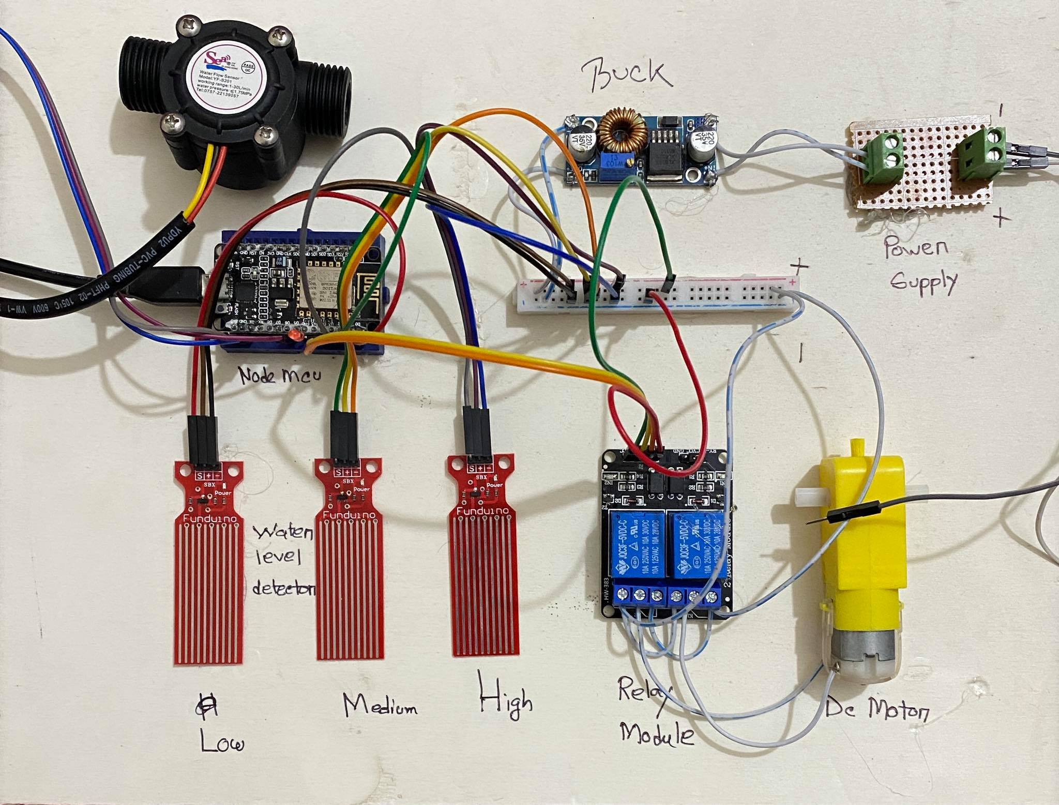

**5. Schematic**

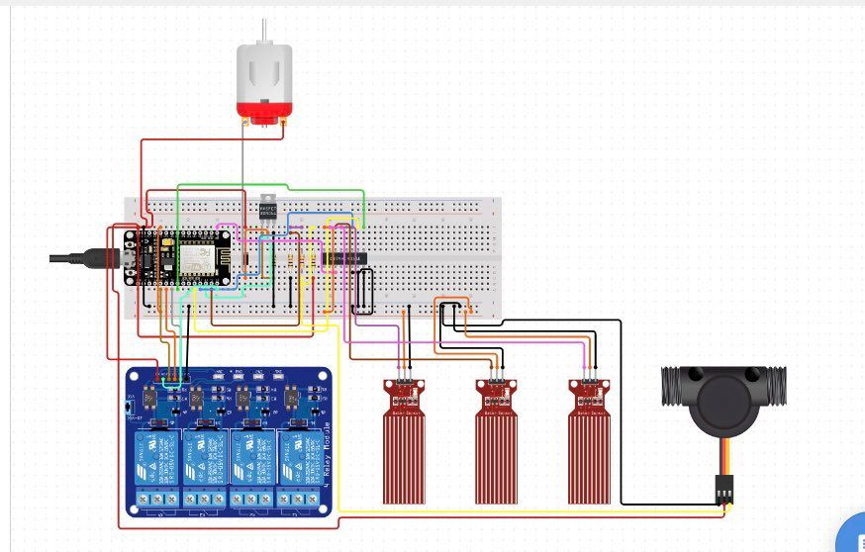

**Fig: Circuit diagram**

**6. Setting up the Blynk Application**

Download the free Blynk App on a laptop from the internet.

Only after the code is pushed, open the blynk app to connect with NodeMCU via wifi.

To login, fill up the login credentials i.e. username and password.

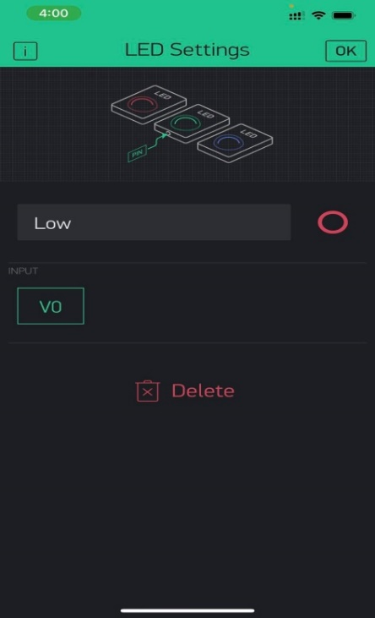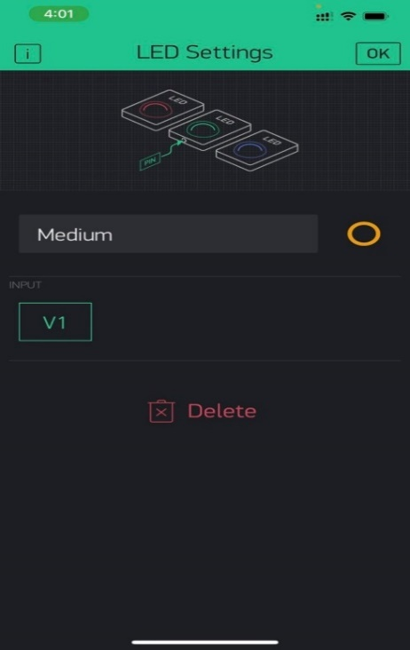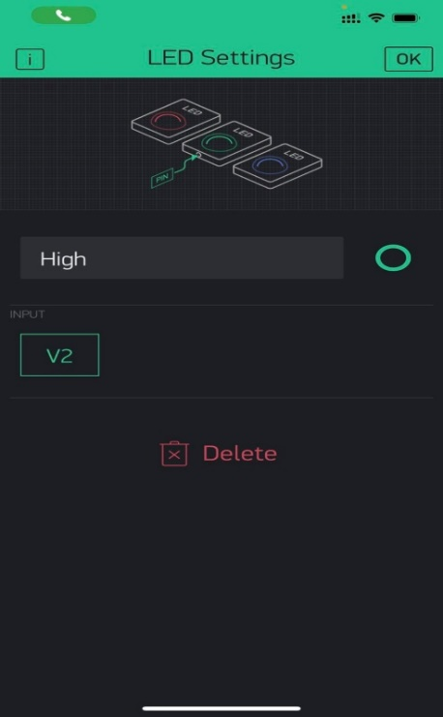

Here, to set up the led in app section, we have used 3 separate input as follows V0, V1 and V2. Which carries 3 different type of light, red for low, yellow for medium and green for full.

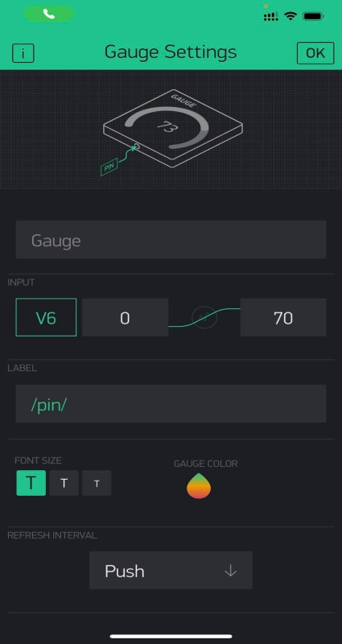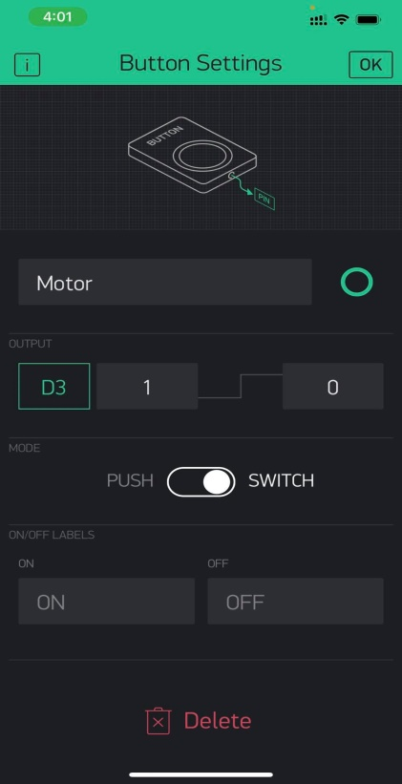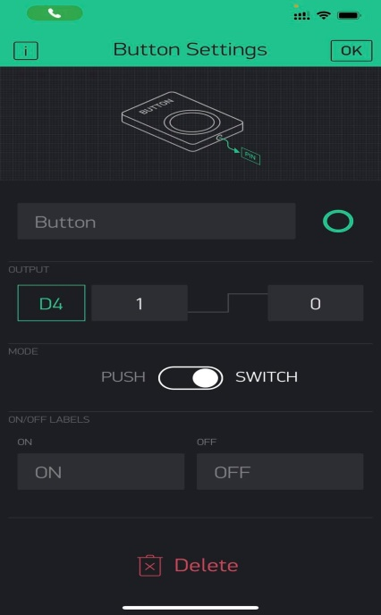  
For monitoring the water flow, we have used Gauge meter with the highest parameter 70 and marked as V6. This is Push based button. Here value will be litter/hour. And for the Motor button we have used D3 and D4 which will operate as turning on or off the motor.

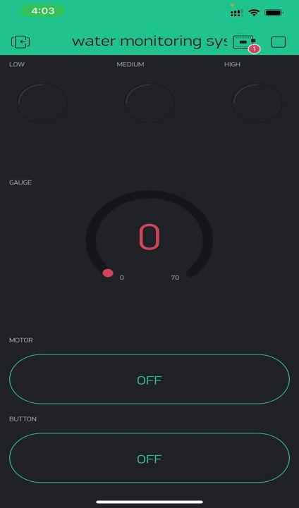

This is the Complete Blynk App, ready for monitoring and controlling water.

**7. Programming the NodeMCU**

The console will appear when NodeMCU is plugged. Click the console to open it and then push the code given below into the console.

**Code:**

|  |
| --- |
| #define BLYNK_PRINT Serial  #include <ESP8266WiFi.h>  #include <BlynkSimpleEsp8266.h>  **int** value1;  **int** value2;  **int** value3;  **const** **int** led = D5;  WidgetLED **led1**(V0);  WidgetLED **led2**(V1);  WidgetLED **led3**(V2);  **char** auth[] = "sNIMXpRB8xFsQnsFNdDYfxMZVWyXTpo6";  // Your WiFi credentials.  // Set password to "" for open networks.  **char** ssid[] = "Mubahere";  **char** pass[] = "error404";  #define SENSOR D6  **long** currentMillis = **0**;  **long** previousMillis = **0**;  **int** interval = **1000**;  **float** calibrationFactor = **4.5**;  **volatile** byte pulseCount;  byte pulse1Sec = **0**;  **float** flowRate;  **unsigned** **long** flowMilliLitres;  **unsigned** **int** totalMilliLitres;  **float** flowLitres;  **float** totalLitres;  **void** IRAM_ATTR **pulseCounter**()  {  pulseCount++;  }  BlynkTimer timer;    **void** **setup**()  {  Serial.begin(**115200**);  timer.setInterval(**1000L**,sendSensor);  Blynk.begin(auth, ssid, pass);  pinMode(led,OUTPUT);  pinMode(SENSOR, INPUT_PULLUP);    pulseCount = **0**;  flowRate = **0.0**;  flowMilliLitres = **0**;  totalMilliLitres = **0**;  previousMillis = **0**;    attachInterrupt(digitalPinToInterrupt(SENSOR), pulseCounter, FALLING);      // Setup a function to be called every second  timer.setInterval(**1000L**, sendSensor);  }    **void** **loop**()  {  value1= digitalRead(D0);  value2=digitalRead(D1);  value3=digitalRead(D2);  Serial.print("Number1:");  Serial.println(value1);  Serial.print("Number2:");  Serial.println(value2);  Serial.print("Number3:");  Serial.println(value3);  **if**(value1==**1**)  {  led1.on();  digitalWrite(led,HIGH);  //Serial.println("LED1: ON");  }  **else** **if**(value2==**1**)  {  led2.on();  //Serial.println("LED2: ON");    }  **else** **if**(value3==**1**)  {  led3.on();  digitalWrite(led,LOW);  // Serial.println("LED3: ON");    }  **else** {    led1.off();  // Serial.println("LED1: off");  led2.off();  // Serial.println("LED2: off");  led3.off();  //Serial.println("LED3: off");    }    Blynk.run();  timer.run();  }  **void** **sendSensor**()  {  currentMillis = millis();  **if** (currentMillis - previousMillis > interval)  {    pulse1Sec = pulseCount;  pulseCount = **0**;  **float** flowRate = ((**1000.0** / (millis() - previousMillis)) * pulse1Sec) / calibrationFactor;  previousMillis = millis();  flowMilliLitres = (flowRate / **60**) * **1000**;  flowLitres = (flowRate / **60**);  totalMilliLitres += flowMilliLitres;  totalLitres += flowLitres;    Blynk.virtualWrite(V6, flowRate);  }  } |

8. Results & Discussion:   
We have identified a suitable implementation model that consists of different sensor devices and other modules, their functionalities are shown in figure. The water level sensor is used to detect and indicate the level of the water in the tank. Sensing is done by using the probes at 3 different levels. Water Flow sensor quantitative measure of total number of water used by specific flat which has been shown in litter per hour. When the water level is medium and low, the main motor for filling up the tank will be start automatically and when the level sensor detect tank is full, device will automatically shut down the motor. To turn off or on the flat water flow we have used another motor to switch off the keys of water which will be placed on terrace. By pressing specific button we can turn it on or off.  
  
**Test Screenshots:**  
Here, water level detector sensor is sending signal to our Mobile App, and the LED is working properly to give us the idea about the water level on Tank.  
  
  
Water flow sensor is giving us the exact amount of water flowing which indicate the real time usage from the specific users. The value showing 22.9 Litter/ Hour is the current usage of the user.

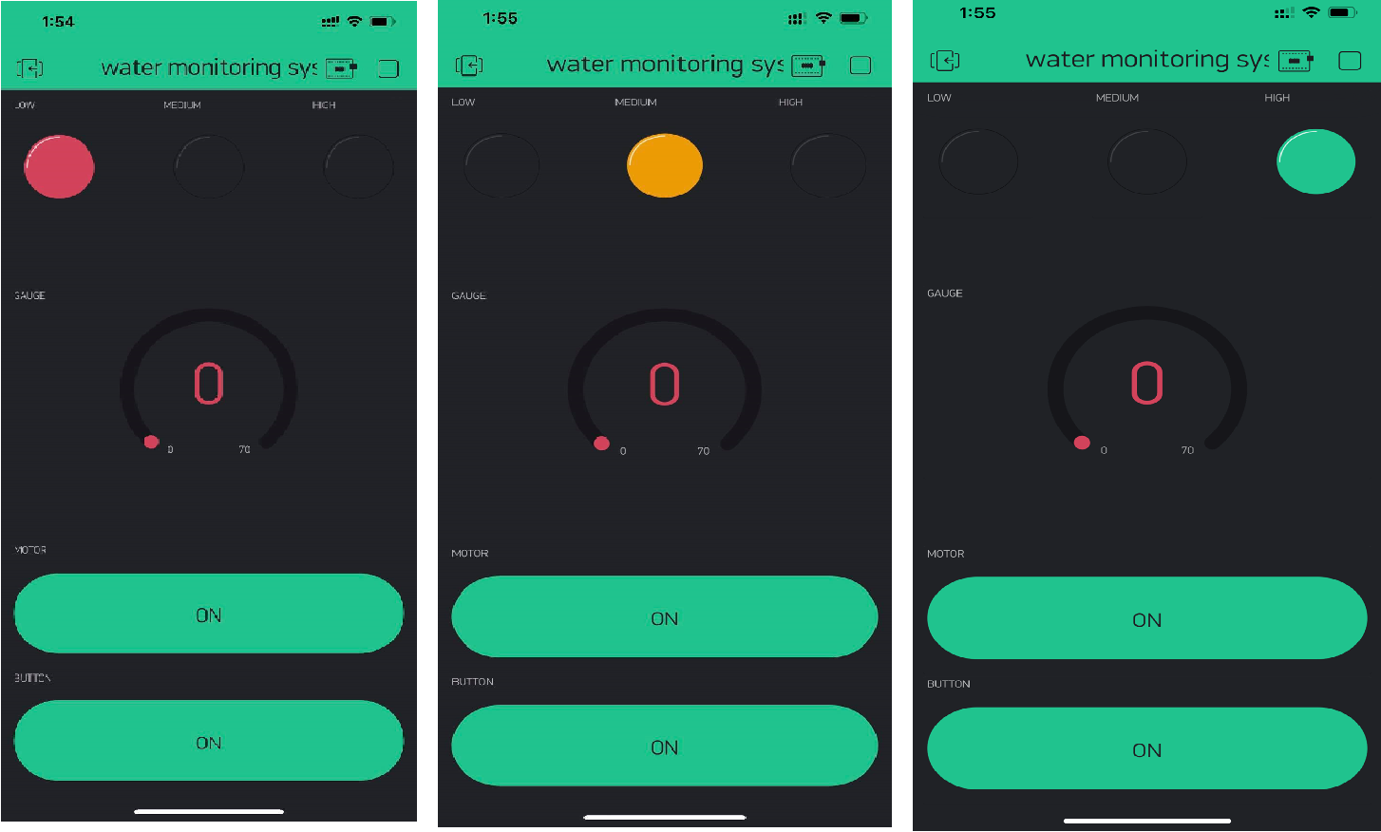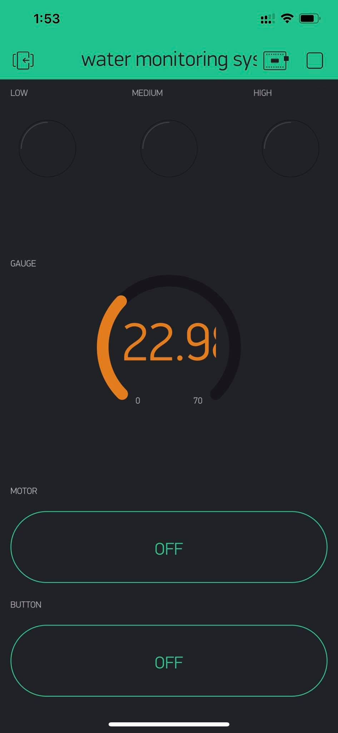

**9. Conclusion & Future Scope:**

The system has good flexibility. Only by replacing the corresponding sensors and changing the relevant software programs, this system can be used to monitor other mass water level for industrial purposes. The conclusion of the parameters of water monitoring system & Automation is verified that the system achieved the reliability and feasibility of using it for the actual monitoring purposes. Monitoring of Water level of tank and water flow makes use of water detection sensor with unique advantage. The sensors control the project, the system can monitor water & control motor automatically, and it is low in cost and does not required people.

Future Scope:

• In future we can use our own Mobile App

• Detecting the more parameters for most secure purpose

• Increase the parameters by addition of multiple sensors

• By upgrading components we can use it for industrial level.

**10. References**

* Tech Ideas, *Simple Water Level Indicator*, *December 25, 2018, Youtube.com.* <https://www.youtube.com/watch?v=7JJWSqo1Wv0&ab_channel=TechIdeas>
* Tech Saw, *Simple Water Level Indicator Without IC & Transistor Using, March 24, 2019, Youtube.com.* <https://www.youtube.com/watch?v=-FAfhvtc7po&ab_channel=TechSaw>
* *IOT Water flow Meter using ESP8266 & Water Flow Sensor,July 9,2019, how2electronics.com.* [*https://how2electronics.com/iot-water-flow-meter-using-esp8266-water-flow-sensor/*](https://how2electronics.com/iot-water-flow-meter-using-esp8266-water-flow-sensor/)
* *Home water monitoring using water flow sensor & nodemcu, January 25, 2019, esp8366.com.* [*https://www.esp8266.com/viewtopic.php?p=80279*](https://www.esp8266.com/viewtopic.php?p=80279)
* TECHY SAM*, How to make a simple water level indicator, May 1, 2017, instructables.com. .*

[*https://content.instructables.com/pdfs/EL7/O78O/J20PJ5AP/How-to-Make-a-Simple-Water-Level-Indicator-1.pdf*](https://content.instructables.com/pdfs/EL7/O78O/J20PJ5AP/How-to-Make-a-Simple-Water-Level-Indicator-1.pdf)